Since our inception, nonprofits have served as the bridge between government and community – a role that has ultimately defined America. As a reliable and trusted source of information, you are uniquely qualified to inform the communities and nonprofits within your network about the vital role that fair and free elections play in sustaining a healthy and equitable civil society.
This toolkit is designed to support your advocacy and mobilization efforts. Curated content and resources included are as follows:
- Talking points and context to support the enclosed policy solutions
- An email template with sample language to support outreach efforts to advocates and stakeholders
- A letter template to support advocacy efforts to Congressional lawmakers
- Social media graphics and sample text to support digital advocacy and engagement
The Issue
State of Play: In 2013 the United States Supreme Court dismantled a key provision of the Voting Rights Act (VRA). The Shelby County v. Holder decision effectively ended the “preclearance” system outlined in Section 5, which required jurisdictions with historical track records of discrimination to obtain federal approval before amending their voting laws. Importantly, however, the 5-4 decision did not strike down Section 5 itself, leaving it to Congress to devise a new coverage formula.
The (H.R. 4 in the 117th Congress) responds to the Court’s directive and provides comprehensive protections against voting discrimination to compensate for the loss of the formula under which states are covered by the preclearance requirement. It’s critically important that Congress restore and modernize the Voting Rights Act to ensure the full promise of the 14th and 15th Amendments are afforded to all who are eligible.

Talking Points & Context
Use the following talking points and context to engage policymakers, constituents, and nonprofit advocates:

The Right to Vote is Not a Partisan Issue, It’s an American Issue.
Every citizen is entitled to an equal opportunity to participate in our democracy. This recent wave of restrictive voting proposals is a part of an ongoing effort to subvert the democratic process. While the preclearance provision of the VRA was not the only tool to combat discrimination in voting, it was certainly an effective one.
- During the 50 years of its enactment the VRA improved minority voter participation and blocked scores of restrictive measures that would have harmed voters.
- Throughout 15 years prior to the 2013 Supreme Court decision, the VRA blocked 86 proposed voting changes and deterred countless more. The Department of Justice blocked 17 changes to election laws in 2012 alone.
Voter Suppression Laws Are Sold As Strengthening Democracy, But They Actually Do the Opposite.
Since the 2013 Shelby County v. Holder decision, states have wasted no time implementing new voting restrictions. Discriminatory policies in voting take many forms, ranging from blatant and open attempts to restrict access to voting among communities of color to more subtle policies that place heavier burdens in marginalized communities.
- Examples of discriminatory voting practices — including new restrictive legislation, discriminatory voter roll purges, long lines and closed polling places, voter intimidation and misinformation, and efforts to overthrow elections through litigation or by invalidating ballots cast by mail— must all be viewed in context when there are obvious statements of intent.
- Each of these instances are evidence of the same underlying problem: the persistence and evolution of unconstitutional racial discrimination in our election system.

The Danger of New Voting Restrictions Is Not Theoretical— It’s a Grim Reality
Since the 2020 election, state lawmakers have introduced and enacted a startling number of restrictive voting bills. Research indicates that 49 state legislatures have introduced over 400 bills with provisions that make it harder to vote, 30 of which have become law in 18 states.
- Despite the historic turnout of the 2020 election, the effects of race discrimination persisted. While voting was at a record high in every racial group, there was a large disparity between white voters and voters of other races. Seventy-one percent of white voters cast ballots in 2020, compared to 58 percent of voters of other races. That gap will only get worse under the new state laws restricting the vote.
- The Supreme Court’s recent decision in Brnovich v. Democratic National Committee weakened Section 2 of the Voting Rights Act, degrading citizens’ ability to challenge policies that lead to voting discrimination.
- Although Shelby County and Brnovich seriously damaged the Voting Rights Act, both decisions determined that Congress has the power to restore and improve the law. In both cases, the Court recognized that the Fourteenth and Fifteenth Amendments gave Congress the power to develop and implement a robust VRA.

Congress Must Act — Without Delay — To Restore the Voting Rights Act
The John Lewis Voting Rights Advancement Act (H.R. 4 in the 117th Congress) is an appropriate, carefully tailored exercise of congressional authority to combat voting discrimination.
- Reintroducing and passing this legislation would restore an essential tool for protecting voting rights. In many instances, the John Lewis Voting Rights Advancement Act would prevent changes to voting rules that discriminate on the basis of race or ethnicity from being implemented. The bill would also restore voters’ ability to challenge discriminatory laws and revive the VRA’s preclearance requirements for voting changes.
- To determine which jurisdictions would be subject to geographic preclearance coverage, the modified VRA replaces the previous static coverage formula with an updated, dynamic formula that covers jurisdictions based on a recent, widespread, and persistent record of violations of the law against discrimination in voting.
- Amendments to Section 2 of the VRA are critical to restore the ability to combat voting discrimination that is not prevented by preclearance. Restoring preclearance provisions and strengthening Section 2 of the original Voting Rights Act would undo much of the damage from the Brnovich and the Shelby County rulings.

Nonprofits Are Trusted Sources of Information — Our Collective Advocacy is More Important Now than Ever
Voting is the cornerstone of a healthy civil society. For two centuries, nonprofits have worked to help our constituents vote because voting ensures elected officials prioritize the needs of our communities and help all people thrive. Research indicates that nonprofit roots and trust within communities provide ample opportunity to increase civic engagement among those who are regularly excluded from the democratic process.
- Our natural engagement assets and unparalleled reach make us particularly well suited to encourage active civic participation.
- As the nation’s third largest employer, nonprofits are able to organize 12.3 million employees and mobilize networks of donors, volunteers, and constituents in every community.
Email & Letter Templates
Urge support for the John Lewis Voting Rights Advancement Act:
Take Action Today
- Submit a letter to your legislators to urge their support for the John Lewis Voting Rights Advancement Act.
- Share this advocacy toolkit with your nonprofit network today to encourage them to take action.

Call-to-Action Email to Advocates
Use the following email templates to support your outreach efforts to organizations in your network and policymakers:
Subject Line: Ask Your Senators: Restore the Voting Rights Act
Dear {Name},
Voting is the cornerstone of a healthy civil society. For two centuries, nonprofits have worked to help our constituents vote because voting ensures elected officials prioritize the needs of our communities and help all people thrive.
The John Lewis Voting Rights Advancement Act (H.R. 4 in the 117th Congress) builds upon one of the most successful pieces of civil rights legislation in our nation’s history. The bill provides much needed mechanisms to review new voting procedures proposed by state and local governments to ensure they do not disproportionately harm the people nonprofits serve, particularly members of low-income, English as a second language, transgender and BIPOC communities.

Sincerely,
{Organization}
Thank You:
Thank you {{contact_first_name}} for supporting our efforts to ensure the full promise of the 14th and 15th Amendments are afforded to all who eligible.

Letter to Congress
Dear {{target_appropriate_greeting}},
I am writing to highlight the urgent need for Congress to restore the Voting Rights Act by passing legislation similar to the John Lewis Voting Rights Advancement Act in the 117th Congress. Voting is the cornerstone of a healthy civil society. For two centuries, nonprofits have worked to help our constituents vote because voting ensures elected officials prioritize the needs of our communities and help all people thrive.
Ensuring every American has a voice in our democracy requires a delicate balance between state and local authority and federal oversight. The John Lewis Voting Rights Advancement Act provides much needed mechanisms to review new voting procedures proposed by state and local governments to ensure they do not disproportionately harm the people nonprofits serve, particularly members of low-income, English as a second language, transgender and communities of color.
It is critically important for Congress to pass federal legislation this year to strengthen oversight of state and local voting laws to prevent barriers to voting before elections occur. As a constituent and member of the nonprofit community, I urge you to support the John Lewis Voting Rights Advancement Act.
Sincerely,
{{contact_full_name}}

Social Media Graphics & Sample Messaging
Use the following messages and graphics to engage in digital advocacy across your organizational platforms:
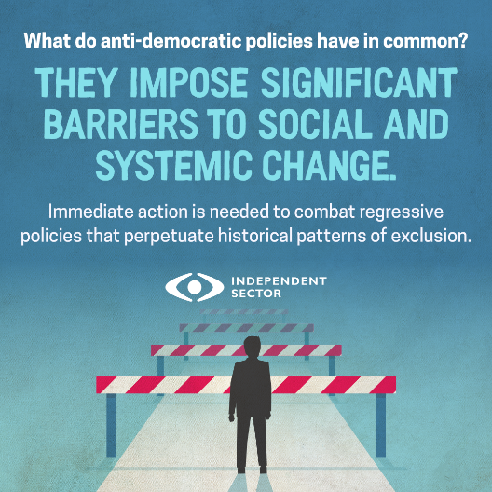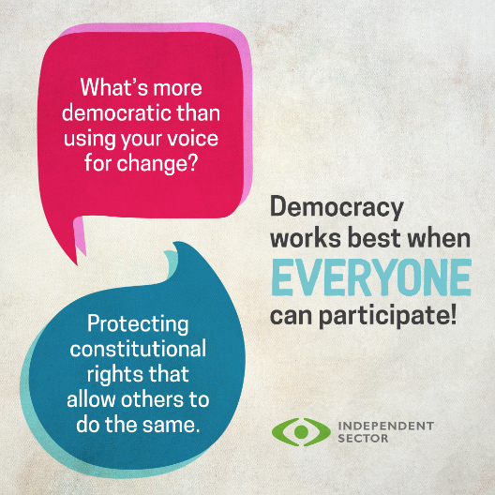
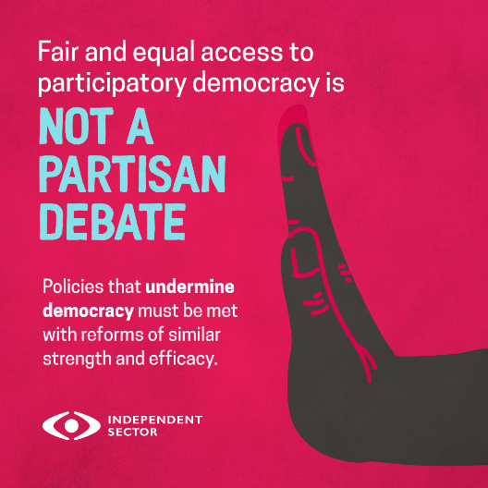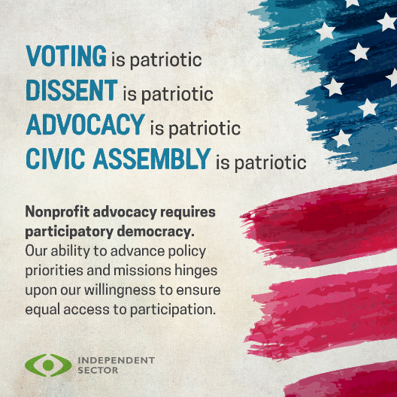
A healthy civil society begins with voter participation. It's critical that Congress passes legislation to strengthen oversight of state & local voting laws to prevent barriers to voting. Take 30 seconds to ask your policymakers to support The John Lewis Voting Rights Advancement Act: https://independentsector.quorum.us/campaign/49022/

Urge Congress to pass The John Lewis Voting Rights Advancement Act to provide mechanisms for new voting procedures proposed by state and local governments to ensure they do not disproportionately harm the people nonprofits serve: https://independentsector.quorum.us/campaign/49022/

