The Retreat of Influence
EXPLORING THE DECLINE OF
NONPROFIT ADVOCACY AND
PUBLIC ENGAGEMENT

2023 Partner Toolkit

The Issue

Nonprofits are a catalyst for democracy and systems change in the United States. Our organizations bring individuals together to educate leaders — particularly policymakers — about our missions, community challenges, and potential solutions. More importantly, for almost 200 years, American nonprofits have endeavored to help people use their own voices to share their stories, call for change, and hold leaders accountable.
Given the influence nonprofits can have on systems and policy, we need to understand the current extent to which nonprofits engage in activities that support systems change. Despite our sector’s legacy and examples of civic activism, a new Independent Sector study shows nonprofits’ advocacy and public engagement is declining.

Advocating for change through the public policy process defines what it means to be a nonprofit. The changes we seek for those we serve rarely come without it. It is a core knowledge – and practice – that is essential for our missions and our survival.

What Can I Do to Help?

This toolkit is designed to make it easy to use and share the research findings from the Retreat of Influence report. This toolkit includes:
- An email template with sample language to support outreach and/or engagement with your network and community
- Template newsletter language about the report and webinar to support outreach and/or engagement with your network and community
- Social media sample posts, graphics and sample text to support digital engagement

Sample Email
Subject Head: New Research Reveals Troubling Decline in Nonprofit Advocacy and Influence
Preheader: Read New Independent Sector Report and Other Resources
An Independent Sector (IS) report released July 18, 2023, highlights the results of a nationally representative survey of nonprofit institutions that finds a significant decrease in nonprofit advocacy and lobbying over the last two decades.

The research report, “The Retreat of Influence: Exploring the Decline of Nonprofit Advocacy and Public Engagement,” fills a 20-year gap in national data on nonprofits’ participation in public policy. It also adds new data on nonprofits’ nonpartisan civic engagement; digital engagement; and diversity, equity, and inclusion (DEI) initiatives.
In addition to exploring the significant decrease in nonprofit advocacy, “The Retreat of Influence” examines how nonprofit advocacy and lobbying interact with other forms of nonpartisan civic engagement.

Among key findings:
- A significantly lower proportion of nonprofits report advocating or lobbying compared to 20 years ago.
- Mission plays the largest role in determining nonprofit advocacy and lobbying.
- Significantly fewer nonprofits know the advocacy activities they can legally do compared to 20 years ago.
- Only 13% of nonprofits conduct nonpartisan activities to help people vote, despite being more effective than other types of organizations at getting people across the political spectrum to vote.
- Nonprofits that belong to collaborative groups advocate at higher rates than those that don’t.
- Although most nonprofits have a diversity, equity, and inclusion (DEI) statement, only 36% engage in policy activities to create more equitable systems.
The report emphasizes nonprofits’ essential role in promoting social change and addressing societal issues and identifies several opportunities for nonprofits to increase their impact.
To learn more, read “The Retreat of Influence: Exploring the Decline of Nonprofit Advocacy and Public Engagement” and other related resources at https://independentsector.co/AdvocacyResearch.

Sample Blurbs for Report and Webinar
Subject Head: New Independent Sector Report Finds Troubling Decline in Nonprofit Advocacy
An Independent Sector (IS) report released July 18, 2023, finds a significant decrease in nonprofit advocacy and lobbying over the last 20 years. The research report, “The Retreat of Influence: Exploring the Decline of Nonprofit Advocacy and Public Engagement,” fills a 20-year gap in national data on nonprofits’ participation in public policy. It also adds new data on nonprofits’ nonpartisan civic engagement; digital engagement; and diversity, equity, and inclusion (DEI) initiatives.

Read the report and other related resources to learn more about the findings, and the opportunities they present for nonprofits to create more equitable systems on behalf of their missions and the communities they serve.
Subject Head: Webinar Tackles Troubling Decline in Nonprofit Advocacy and Influence
A new Independent Sector (IS) report reveals a significant drop in nonprofit advocacy and engagement. What are the reasons for this retreat from advocacy, and how can we reverse the decline?
Register today for an important webinar, Wednesday, July 26 at 1:00 p.m. ET that will examine the results of Independent Sector’s new report, “The Retreat of Influence: Exploring the Decline of Nonprofit Advocacy and Public Engagement.” The report’s authors, IS President and CEO Dr. Akilah Watkins, Bauman Foundation Executive Director Emeritus Gary Bass, and other sector leaders will unpack the report’s unsettling findings. They’ll also consider opportunities for nonprofits to use our advocacy voice to create more equitable systems on behalf of our missions and communities we serve.
Social Media Graphics & Sample Messaging
Use the following messages and graphics to engage in digital advocacy across your organizational platforms:

Hashtags:
- #Advocacy
- #Nonprofit
- #PublicPolicy
- #SystemsChange
- #RiseorRetreat

Handles
- Facebook: @IndependentSector
- Twitter: @IndSector
- Instagram: @IndependentSector

Key Findings Graphics:

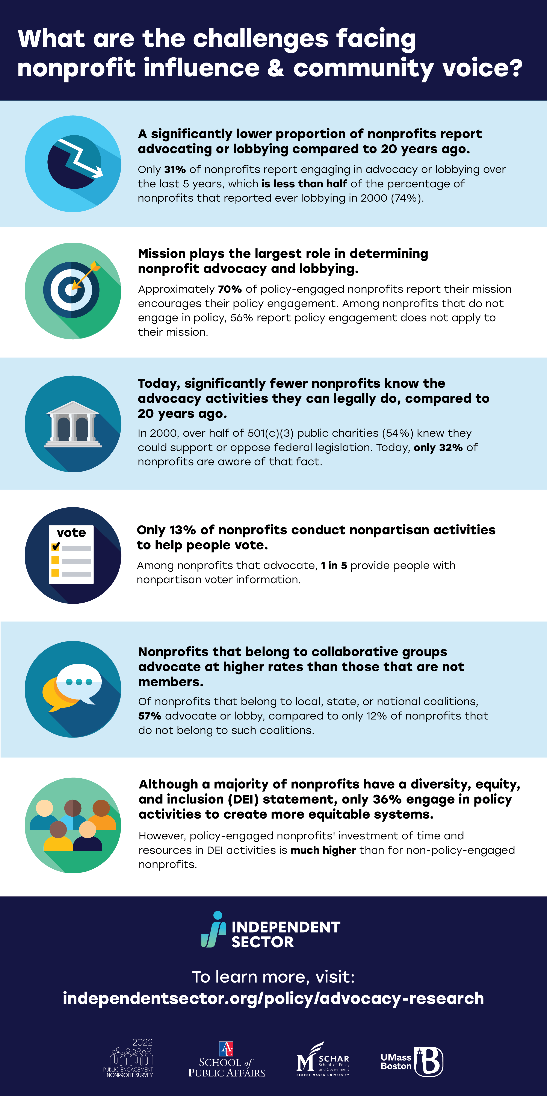
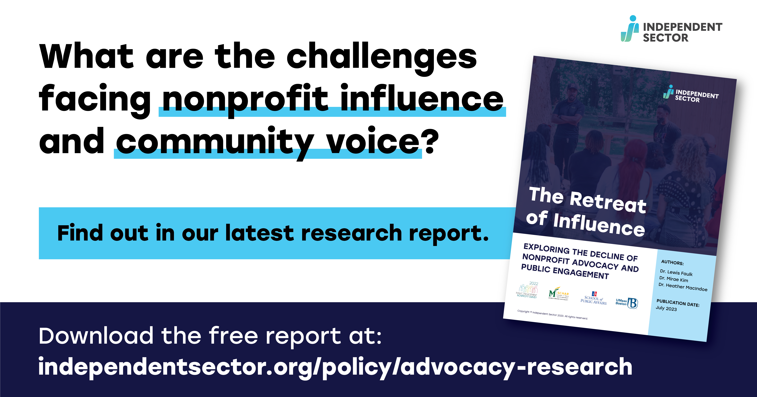

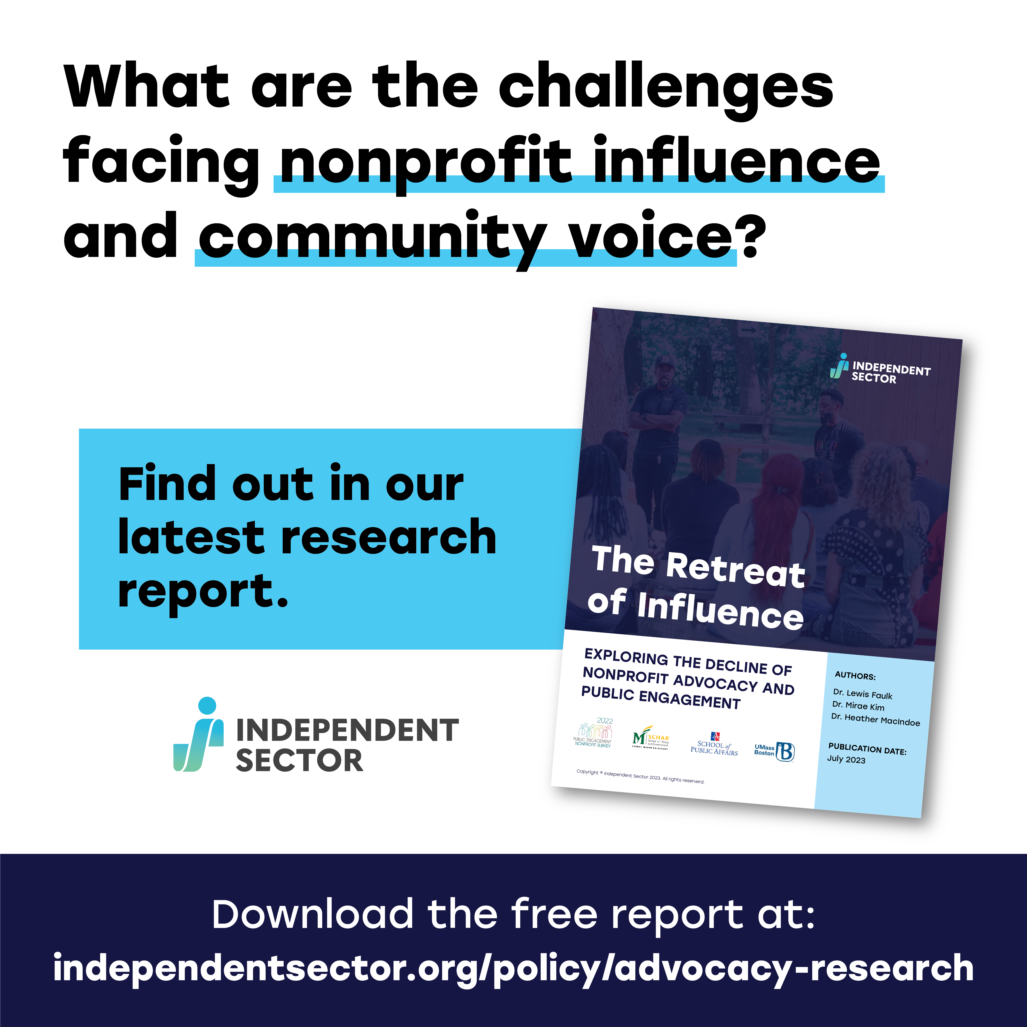
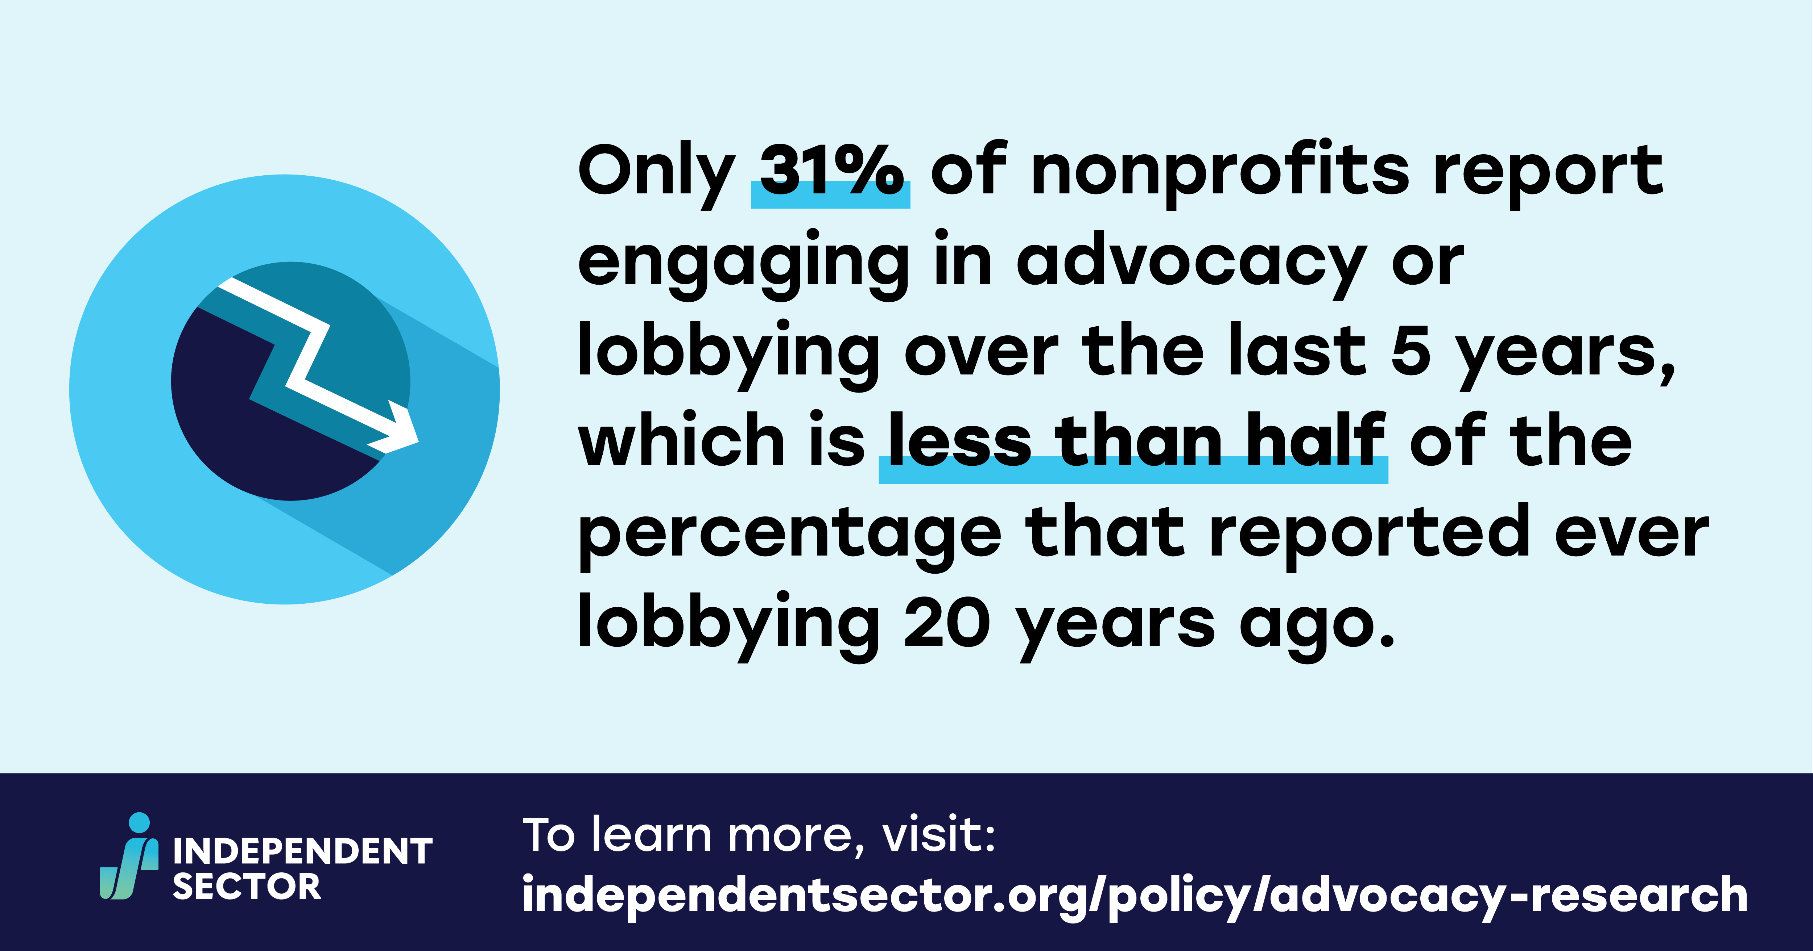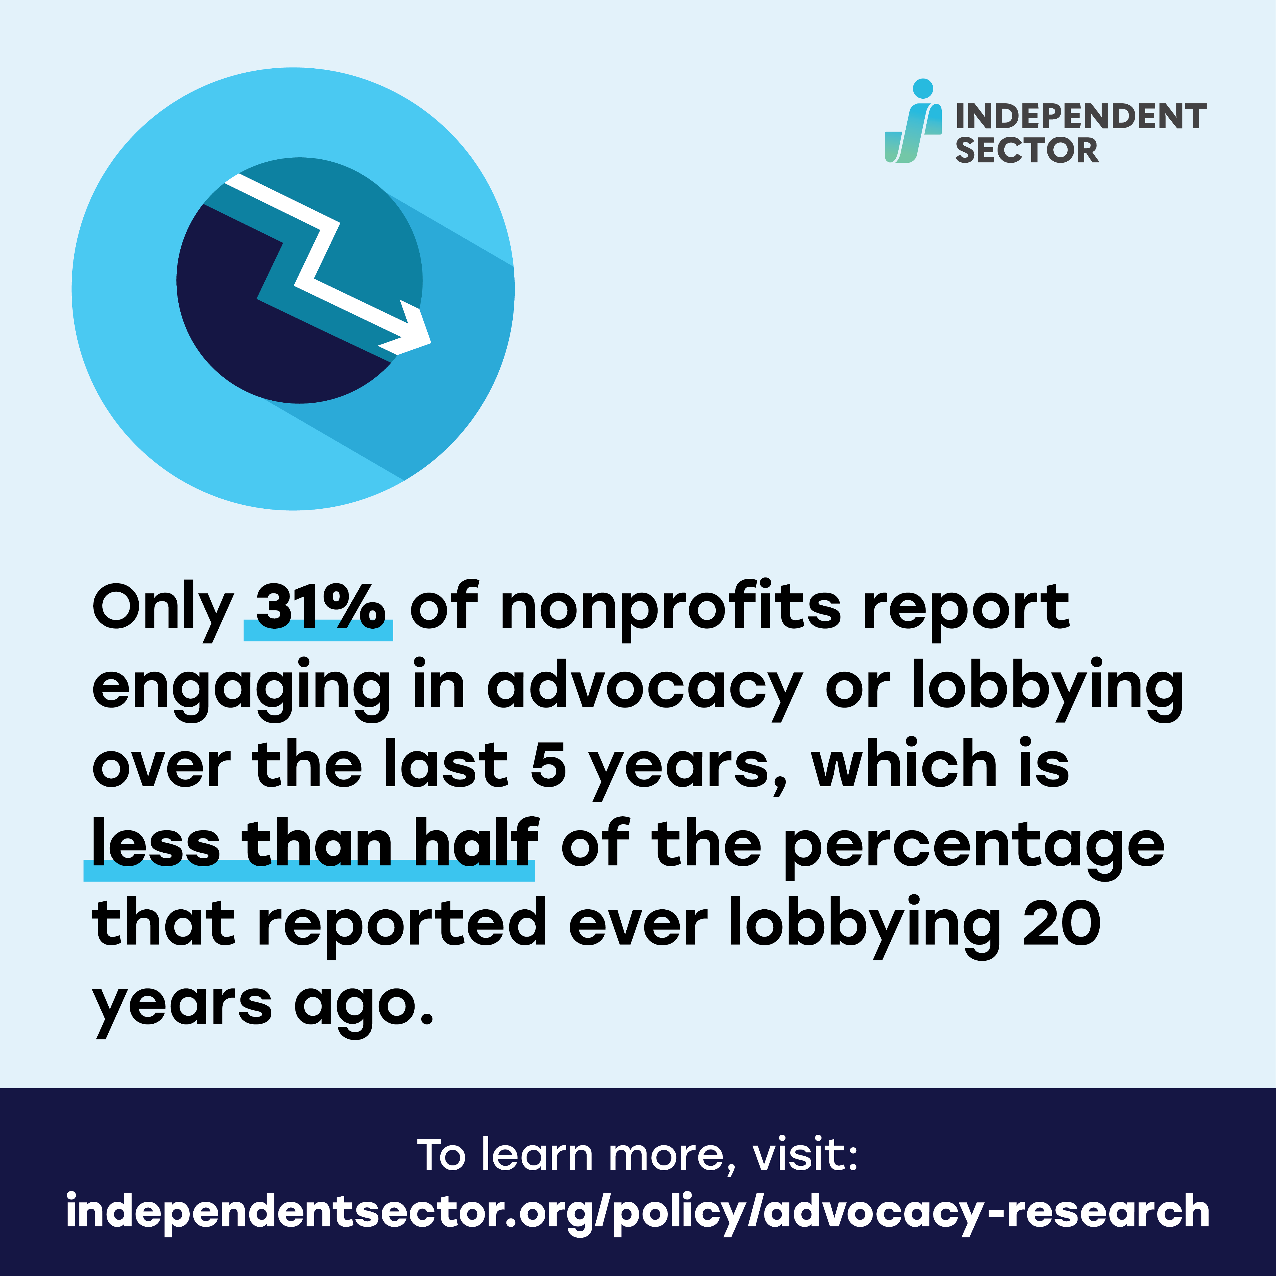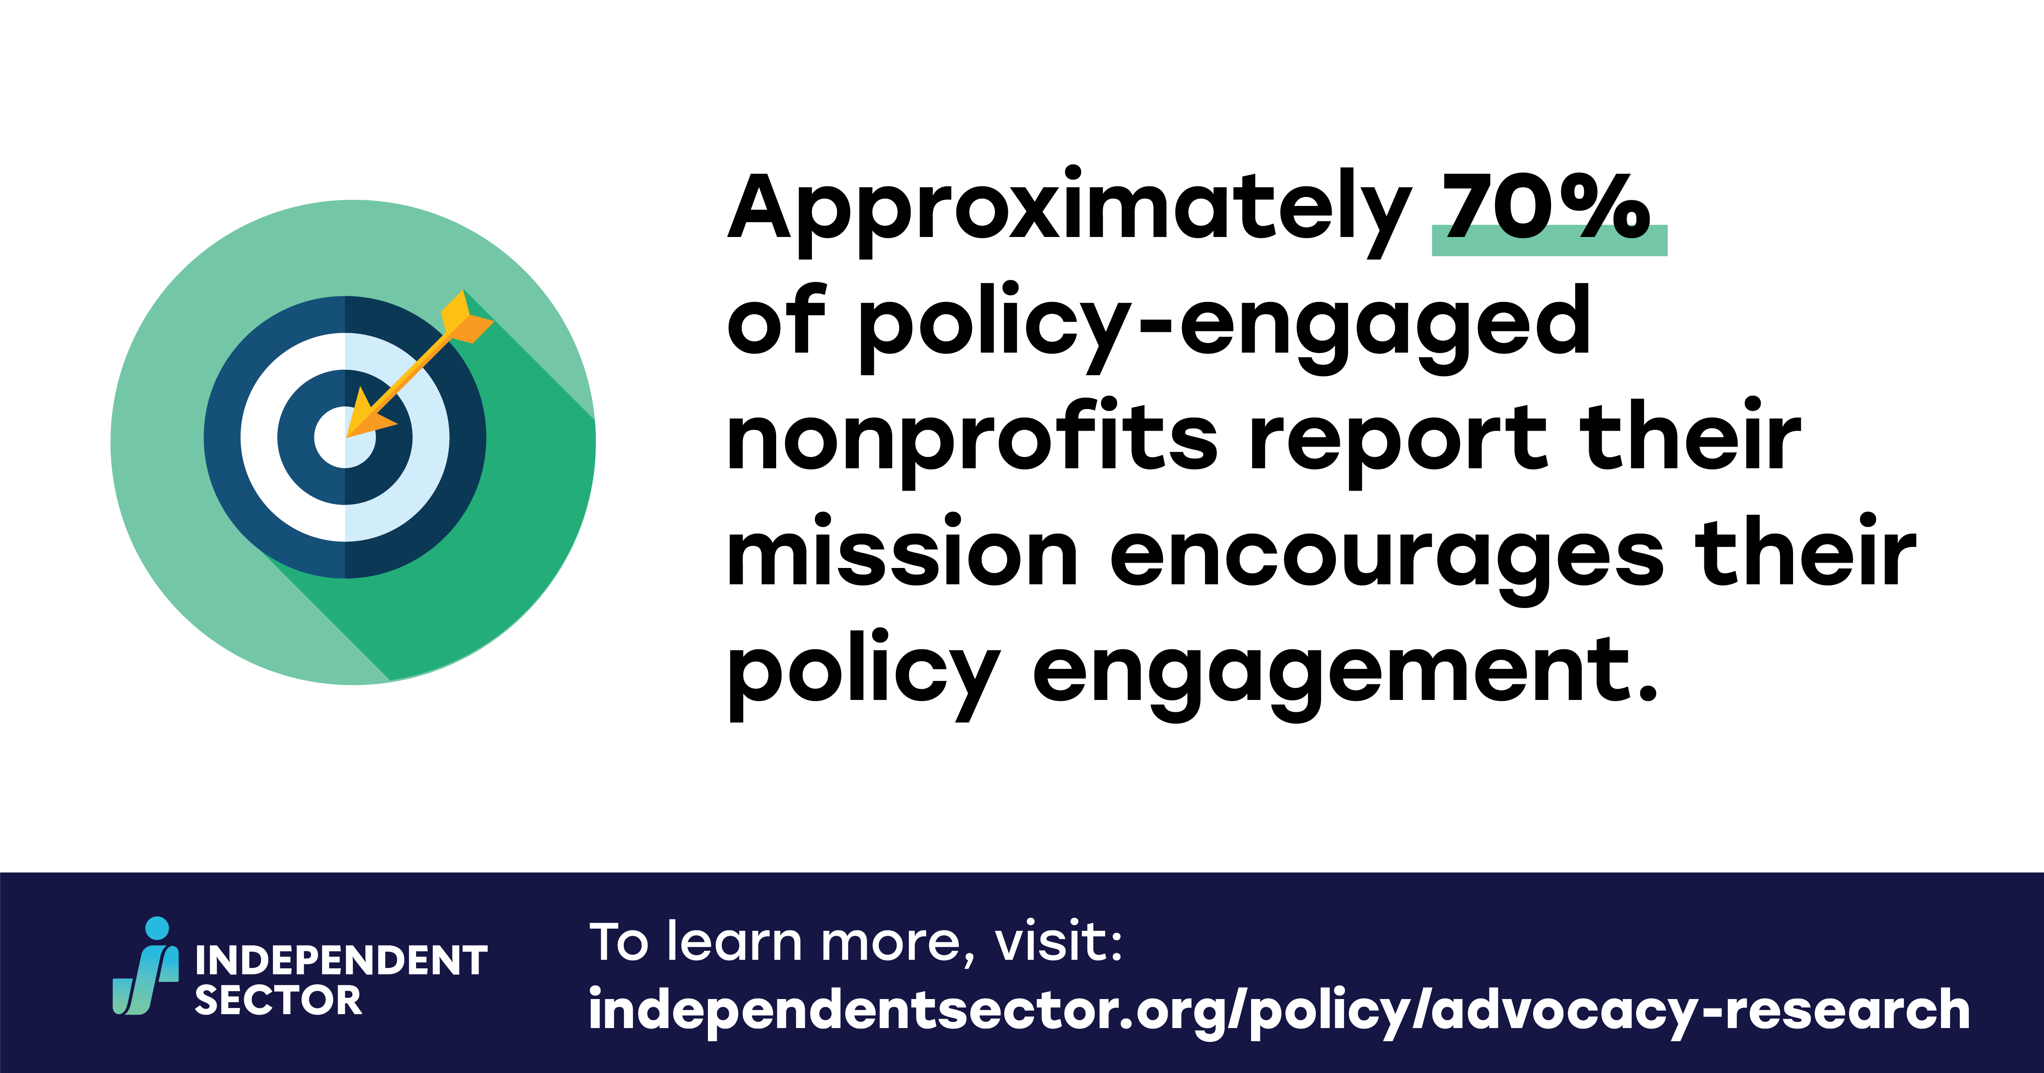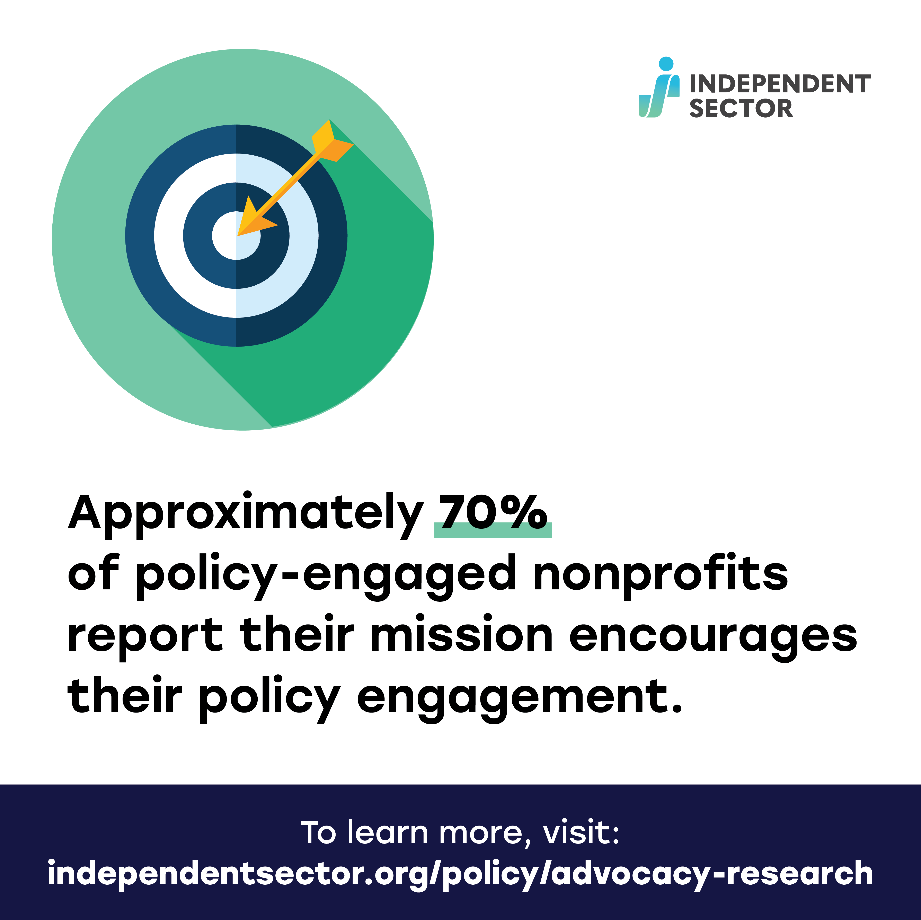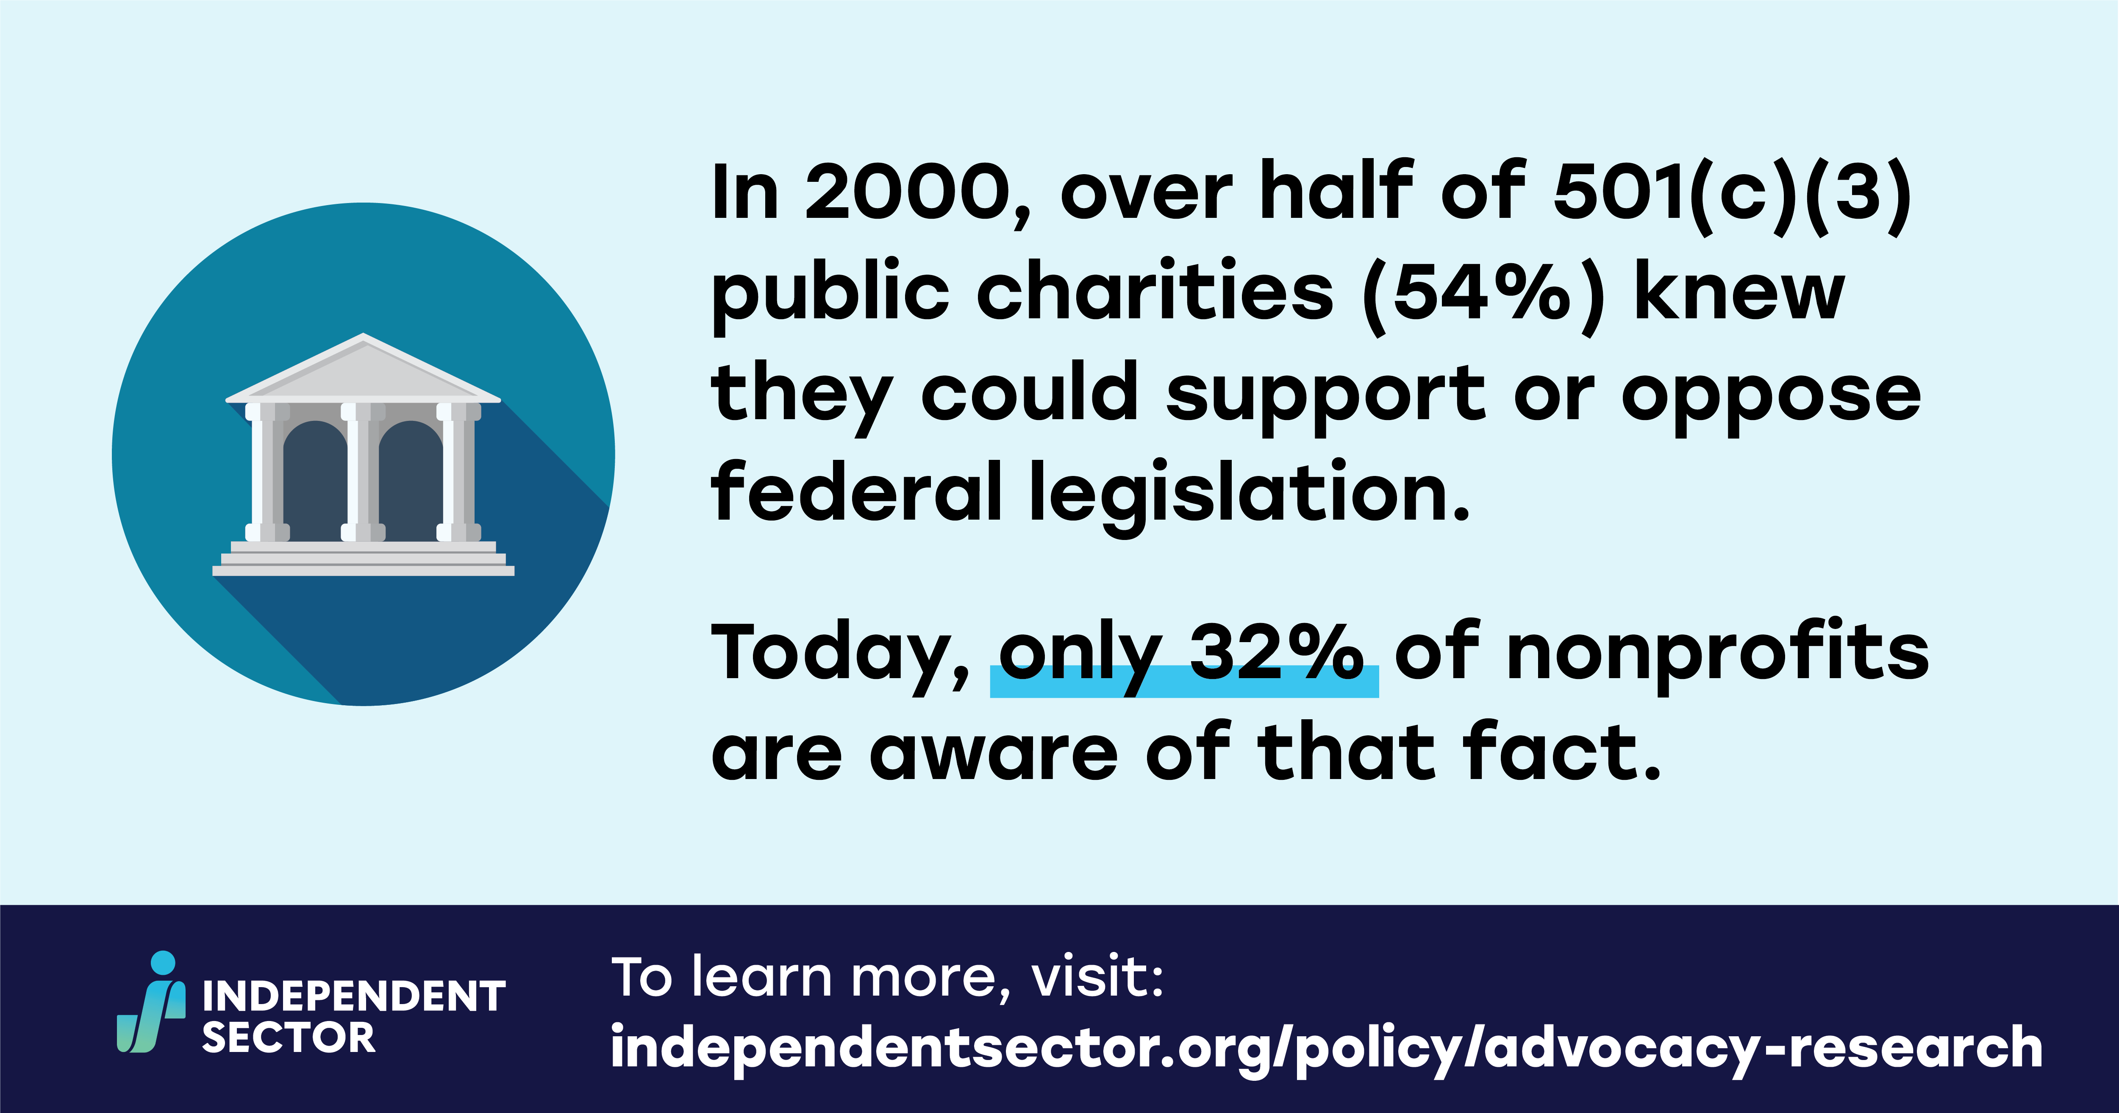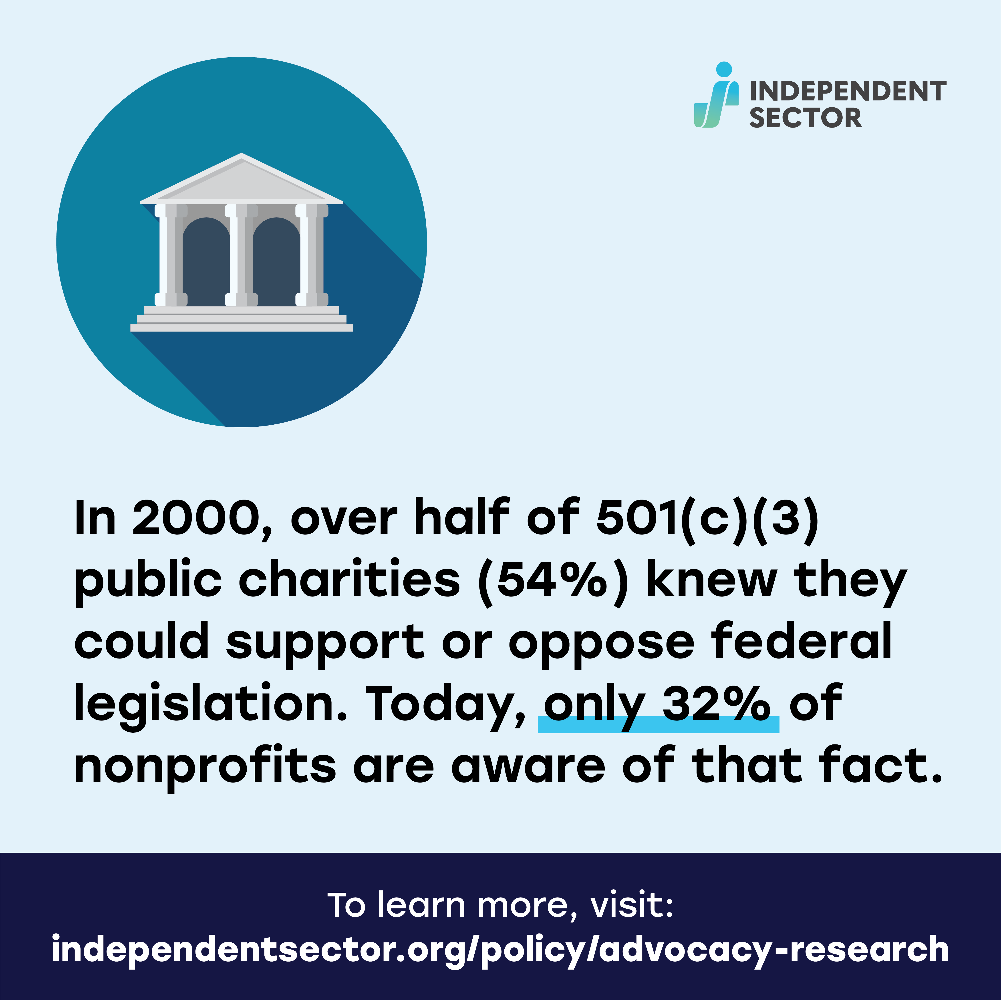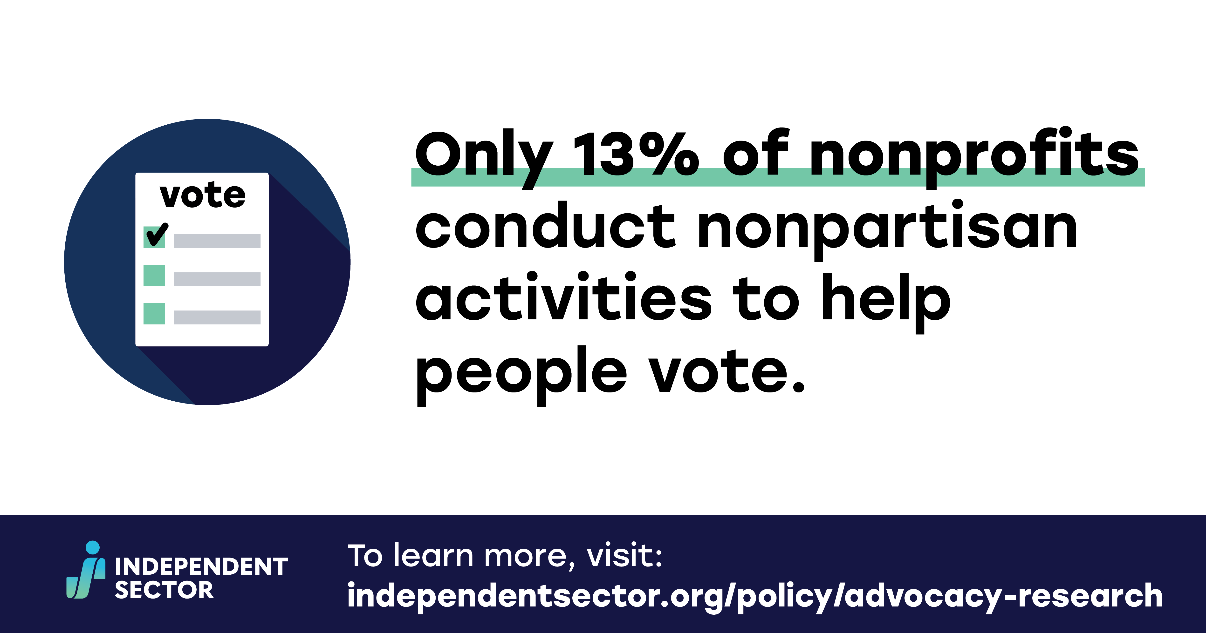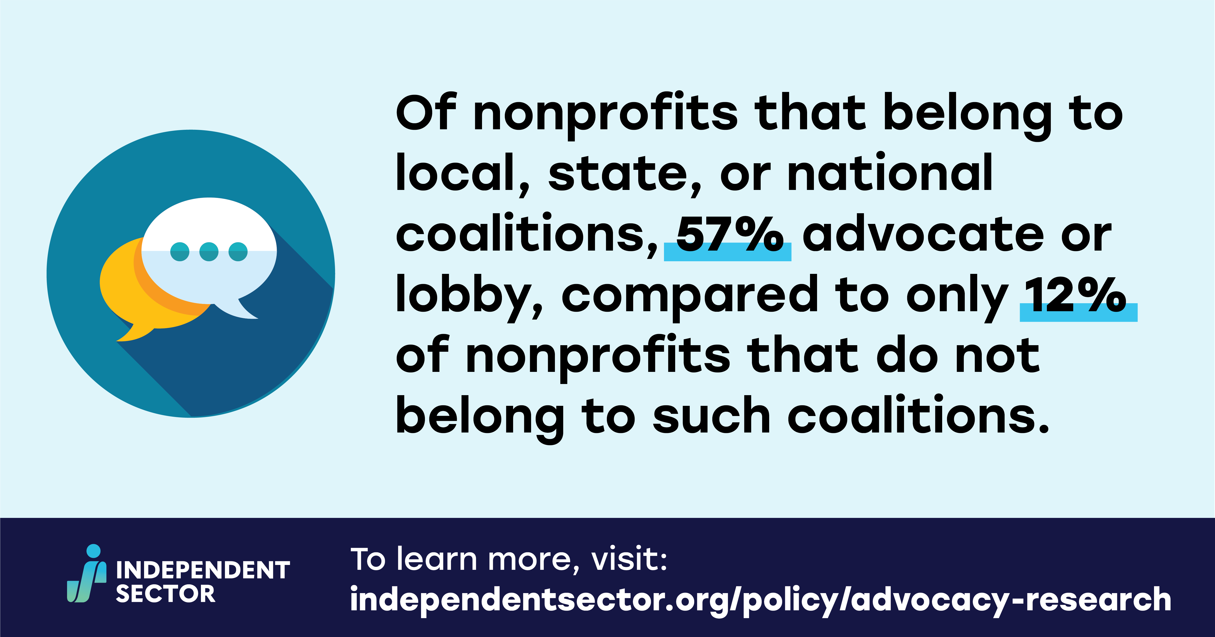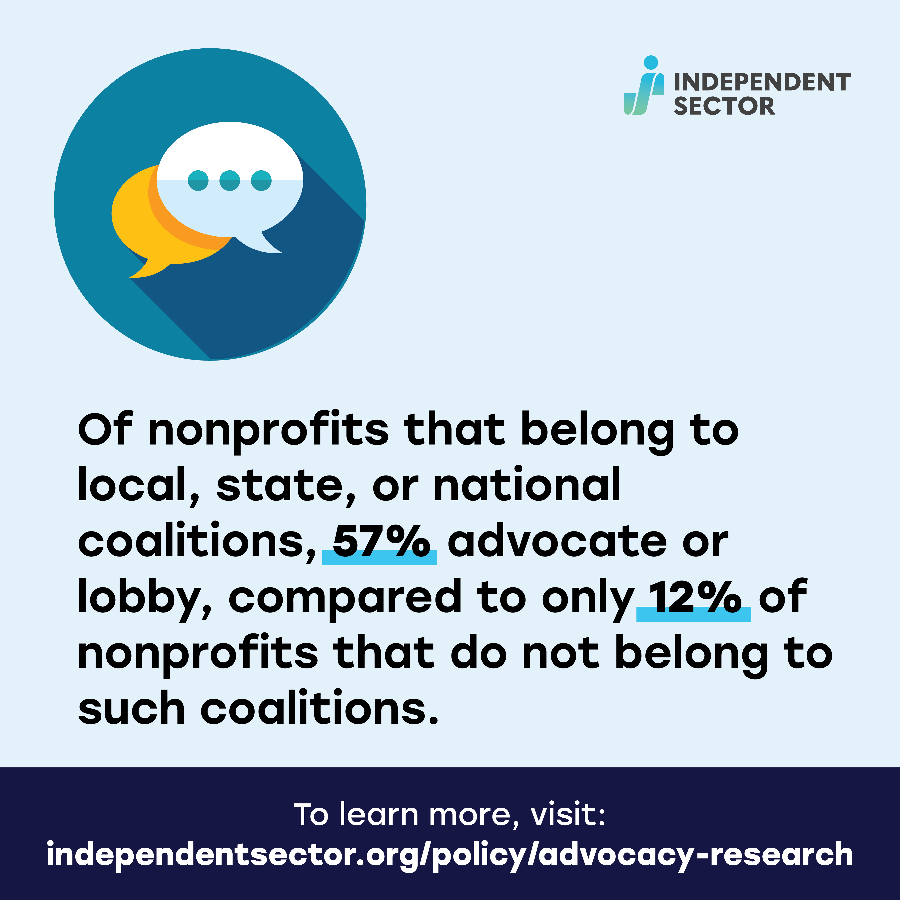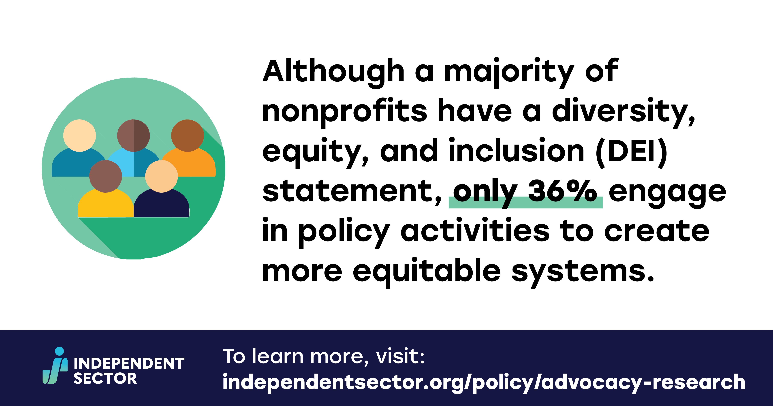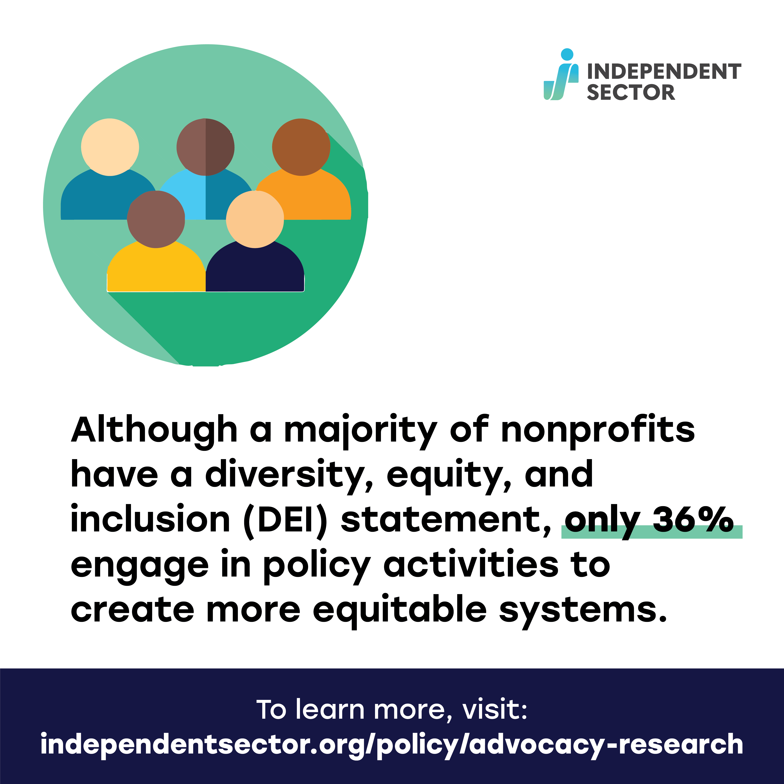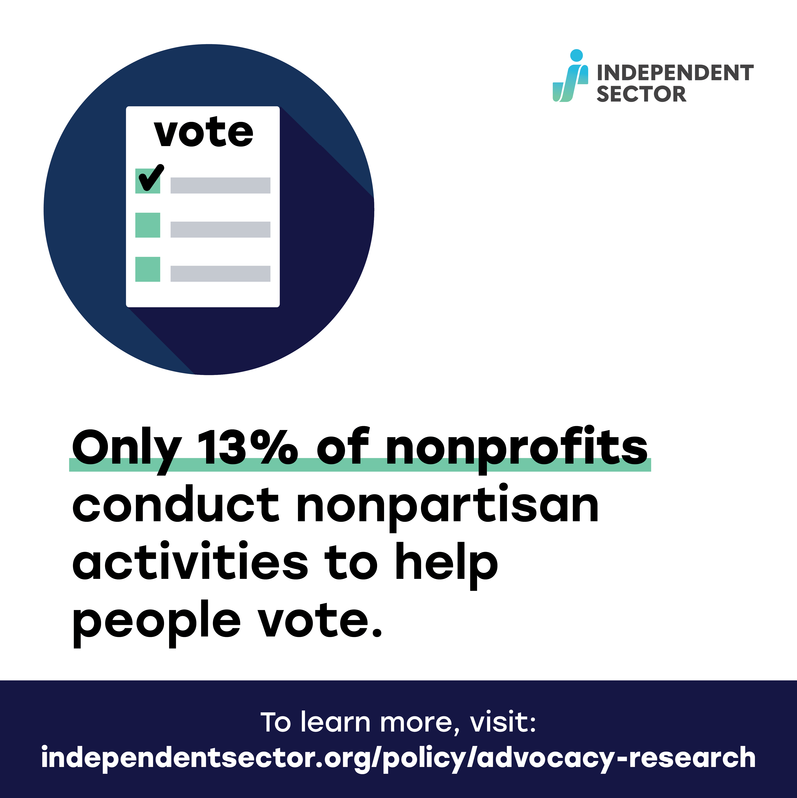

Sample Posts:

General Promotional Posts:

Facebook, Instagram, and LinkedIn
- Have you heard? Independent Sector released the results of a #research survey that finds a significant decrease in #nonprofit engagement in #advocacy and #lobbying over the last 20 years. The “The Retreat of Influence: Exploring the Decline of Nonprofit Advocacy and Public Engagement” report fills a 20-year gap in national data on nonprofits’ participation in public policy. Read the full report https://independentsector.co/AdvocacyResearch #IndSector #RiseorRetreat
- #ICYMI Independent Sector released the “The Retreat of Influence: Exploring the Decline of Nonprofit Advocacy and Public Engagement” report. This IS exclusive #research report finds that only 36% of #nonprofits engage in policy activities to create more equitable systems. Learn more about the #advocacy gap in nonprofits in the full report https://independentsector.co/AdvocacyResearch #IndSector #RiseorRetreat

- #Advocacy and public engagement are the backbone of #nonprofit work. Unfortunately, our newest #research shows a decline in nonprofit advocacy work. Read Independent Sector’s newest research report, filling a 20-year gap in national data on nonprofits’ participation in public policy https://independentsector.co/AdvocacyResearch #IndSector #RiseorRetreat

Twitter:
- #ICYMI @IndSector’s latest #nonprofit advocacy research report is out NOW! Learn more about the #advocacy decline by nonprofits in the full report https://independentsector.co/AdvocacyResearch #IndSector #RiseorRetreat
- #DYK there’s been a significant decrease in #advocacy by #nonprofits in the last 20 years? Learn more in the newest @IndSector research report https://independentsector.co/AdvocacyResearch #IndSector #RiseorRetreat

- #Nonprofits are essential to promoting #socialchange in our country through #policy #advocacy. Read the latest research from @IndSector on the role of advocacy w/n the nonprofit space https://independentsector.co/AdvocacyResearch #IndSector #RiseorRetreat

Quote Promotional Posts:
- Facebook/LinkedIn/Twitter
- Caption: 📣 Nonprofit Advocacy Report Endorsement 📣 *Insert quote and name* Read the full report here ➡️https://independentsector.co/AdvocacyResearch #RiseorRetreat #IndSector
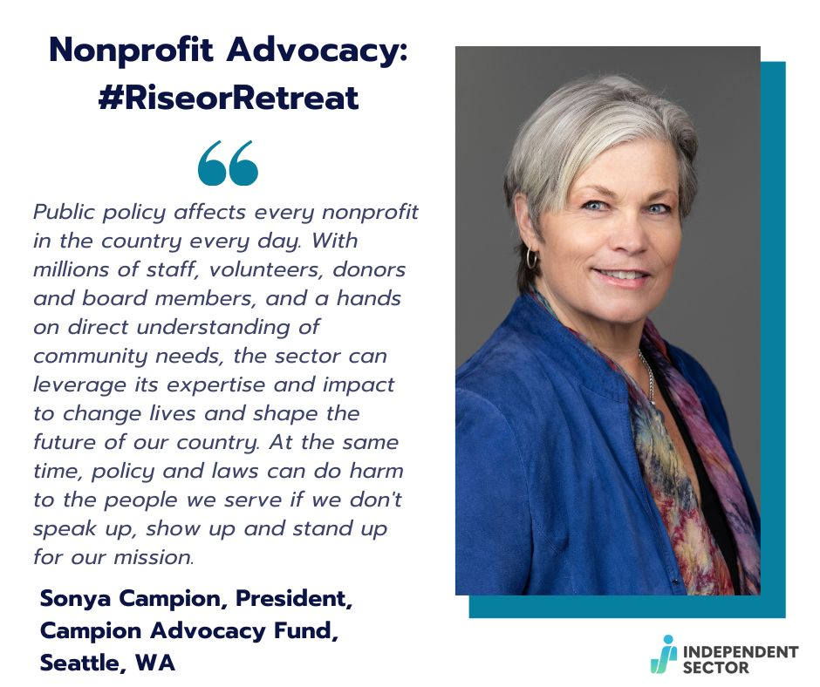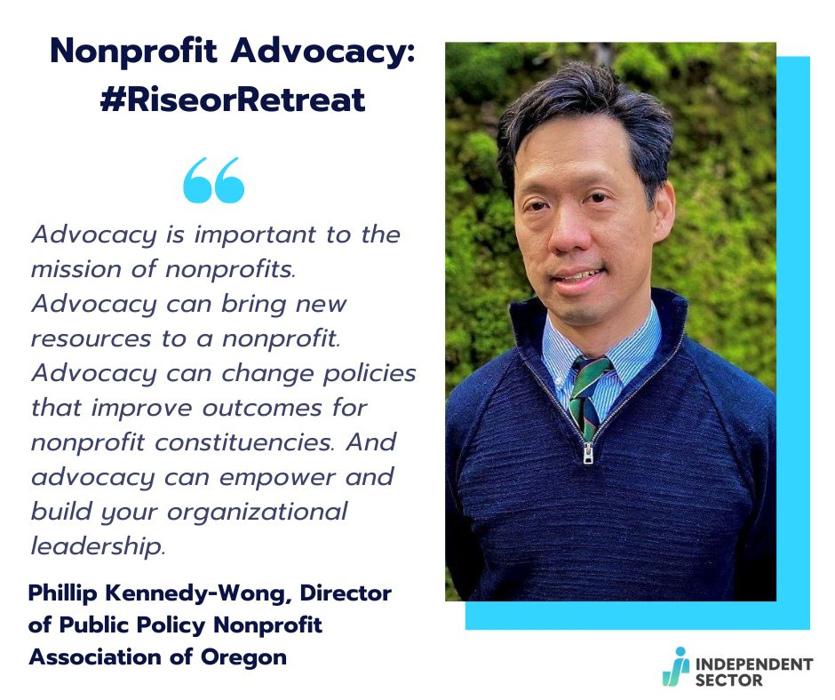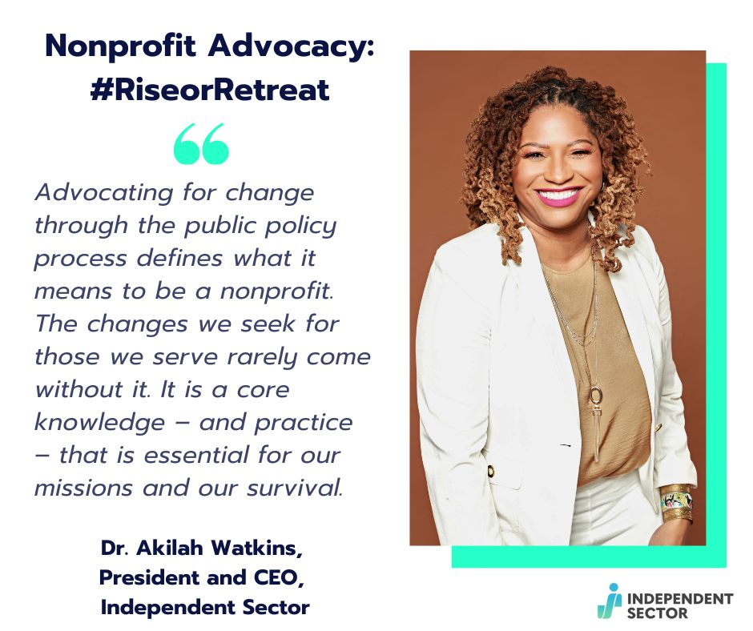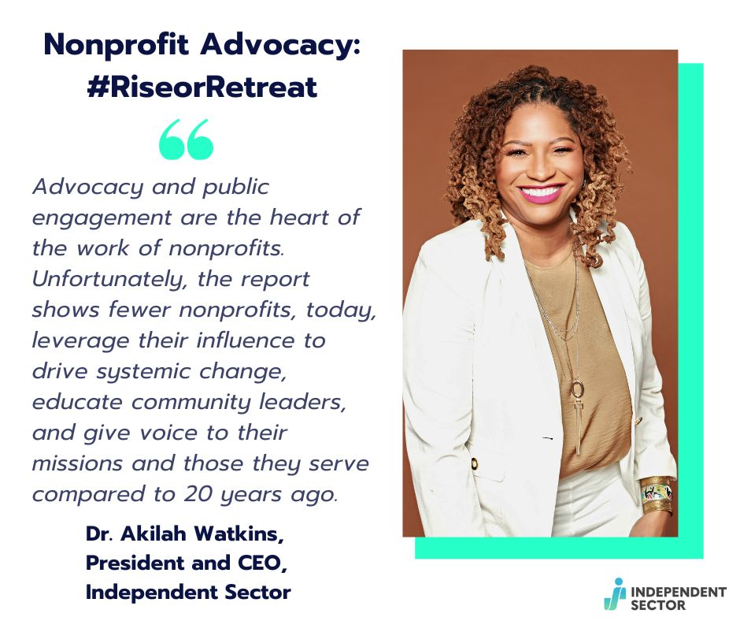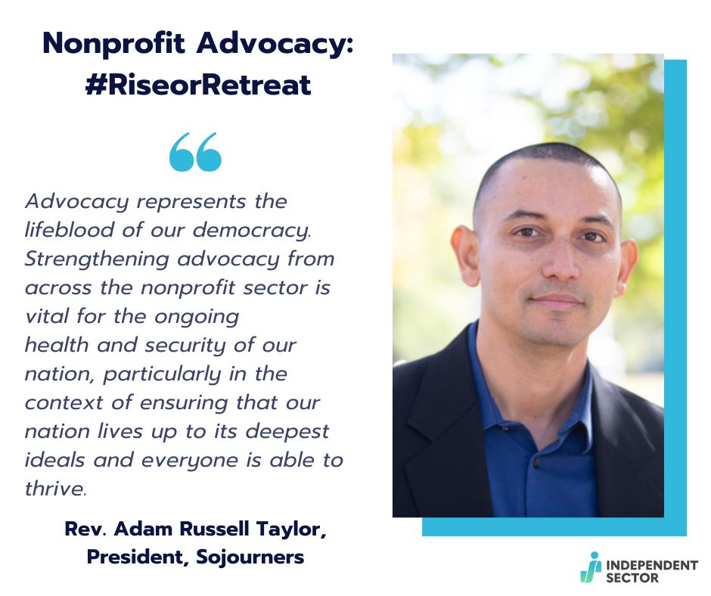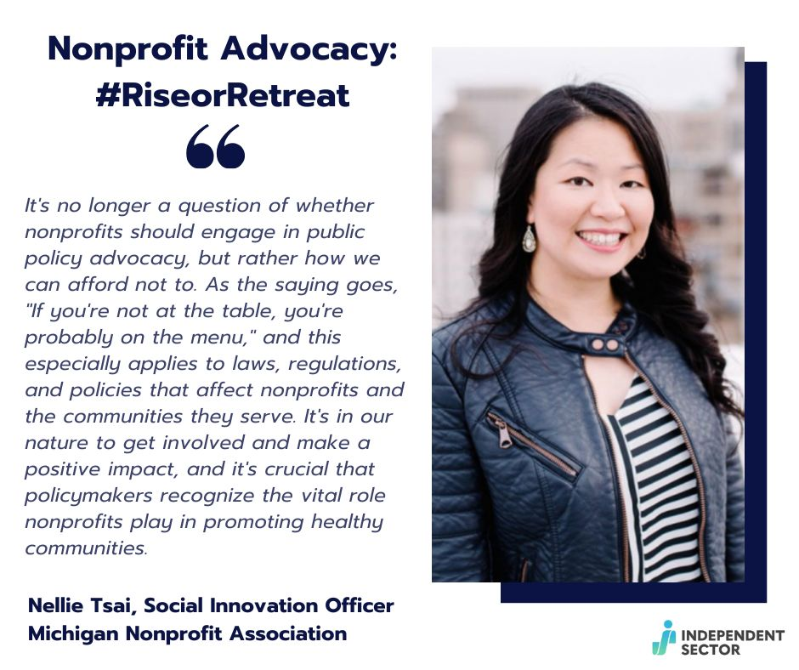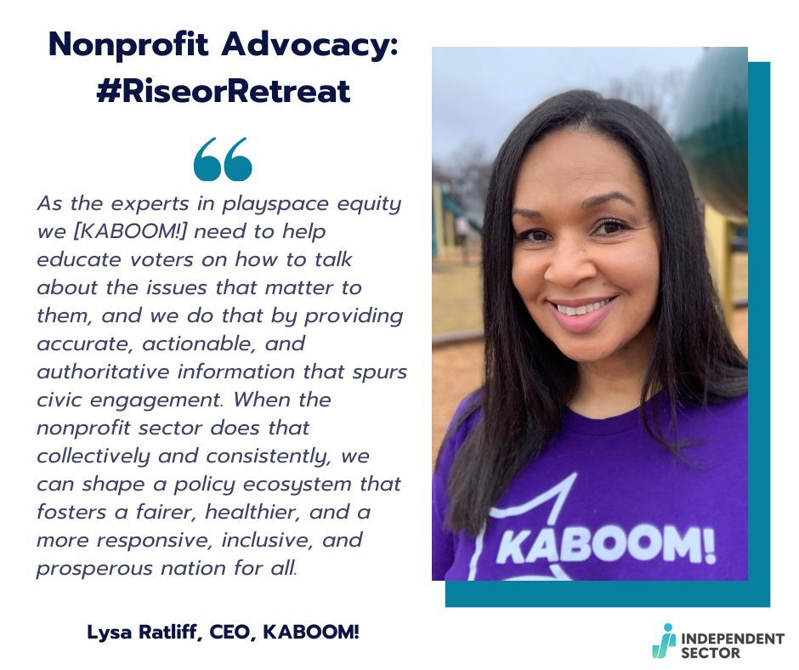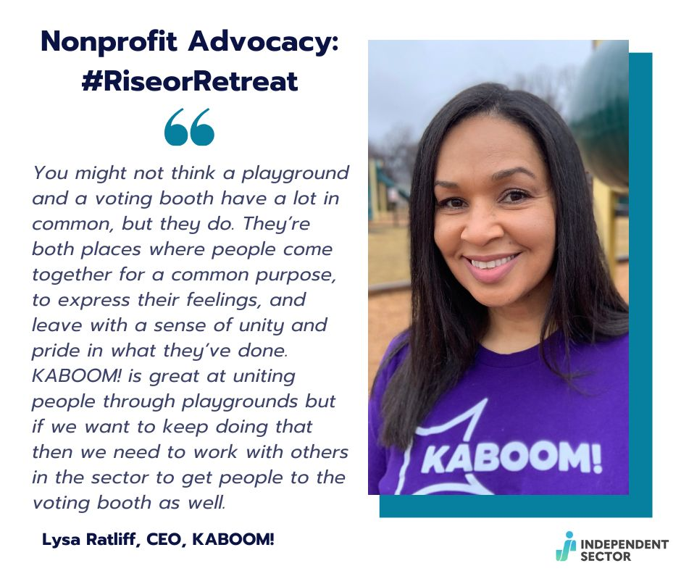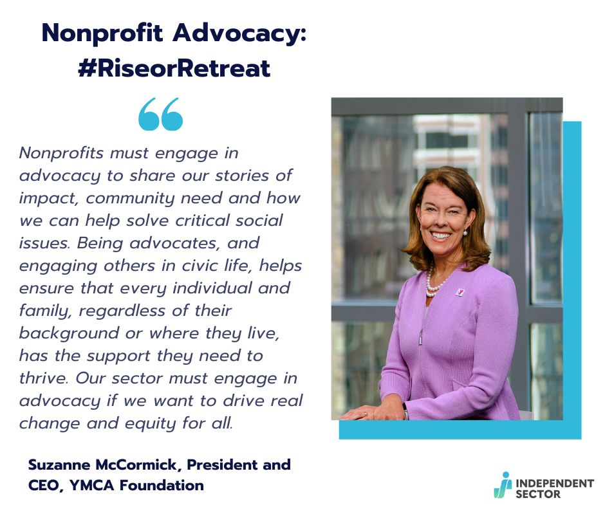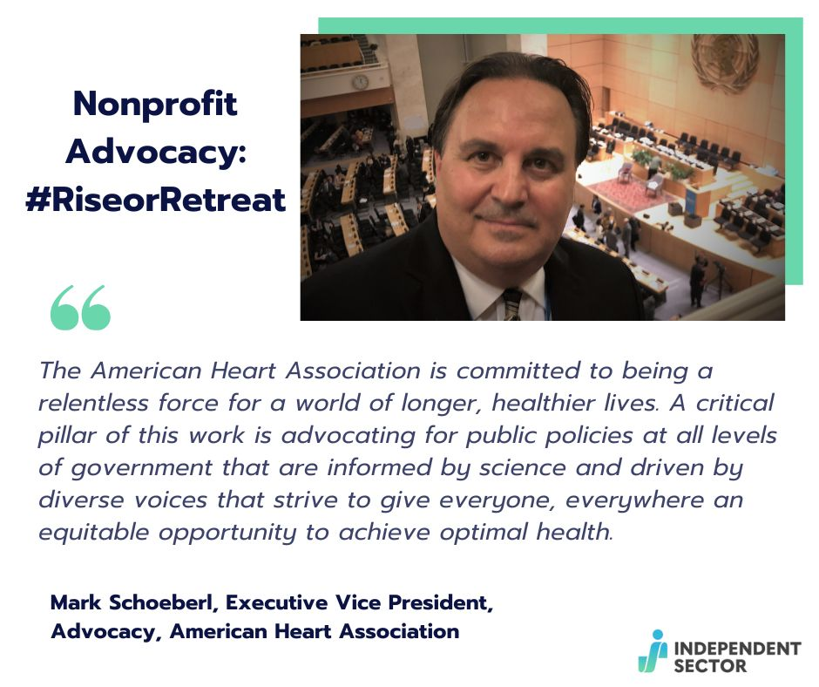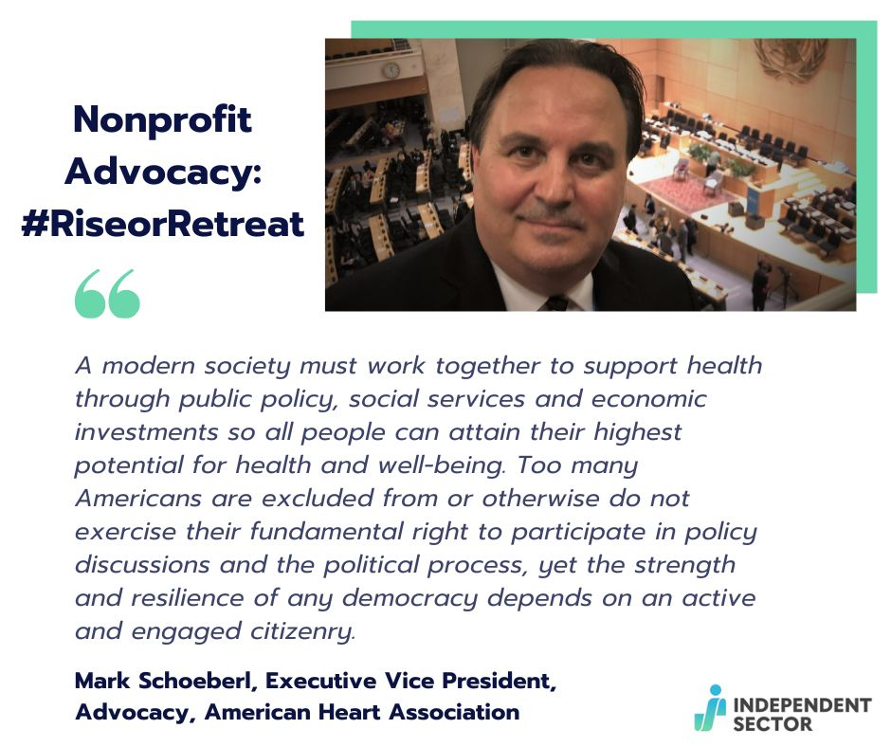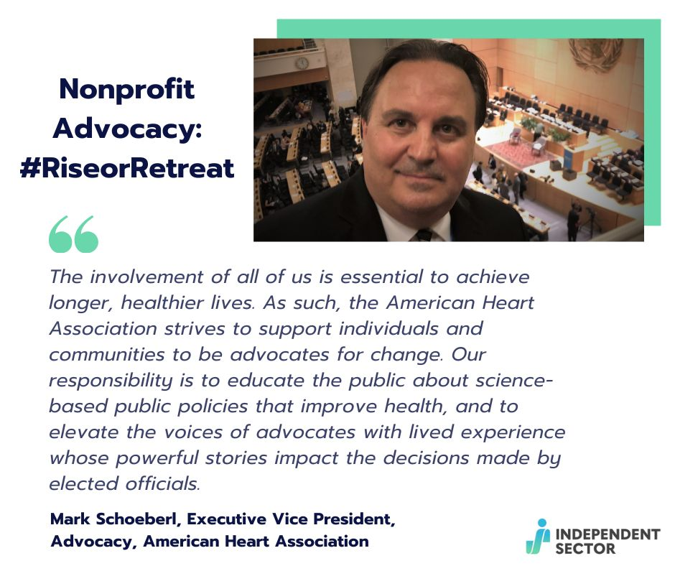

- Note that Twitter may have to be a thread of the quote or just eliminate the quote as copy for ease

- Instagram
  - Caption: 📣 Nonprofit Advocacy Report Endorsement 📣 *Insert quote and name* Read the full report using the link in our bio! #RiseorRetreat #IndSector

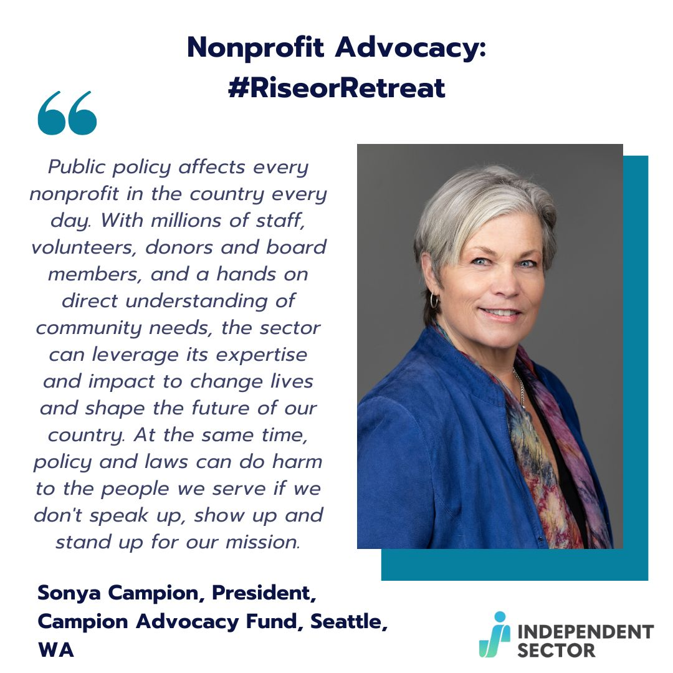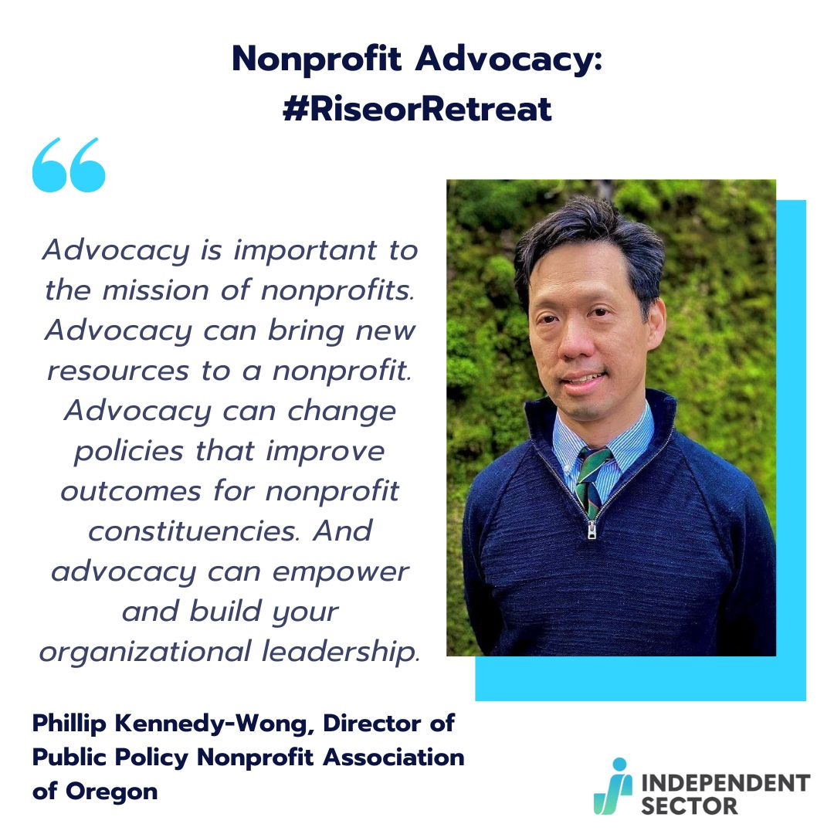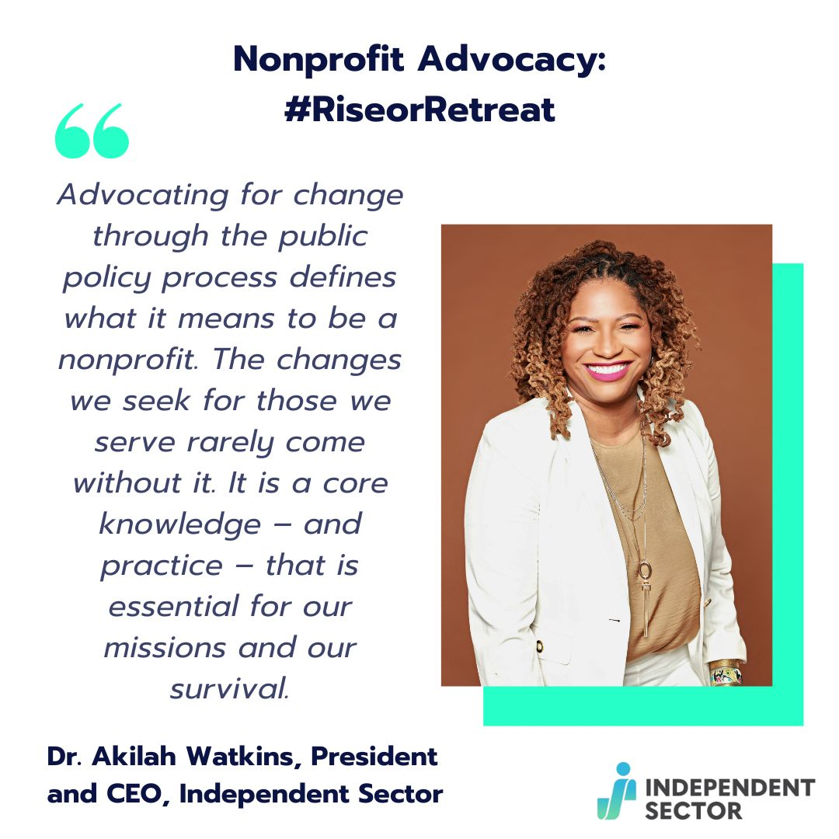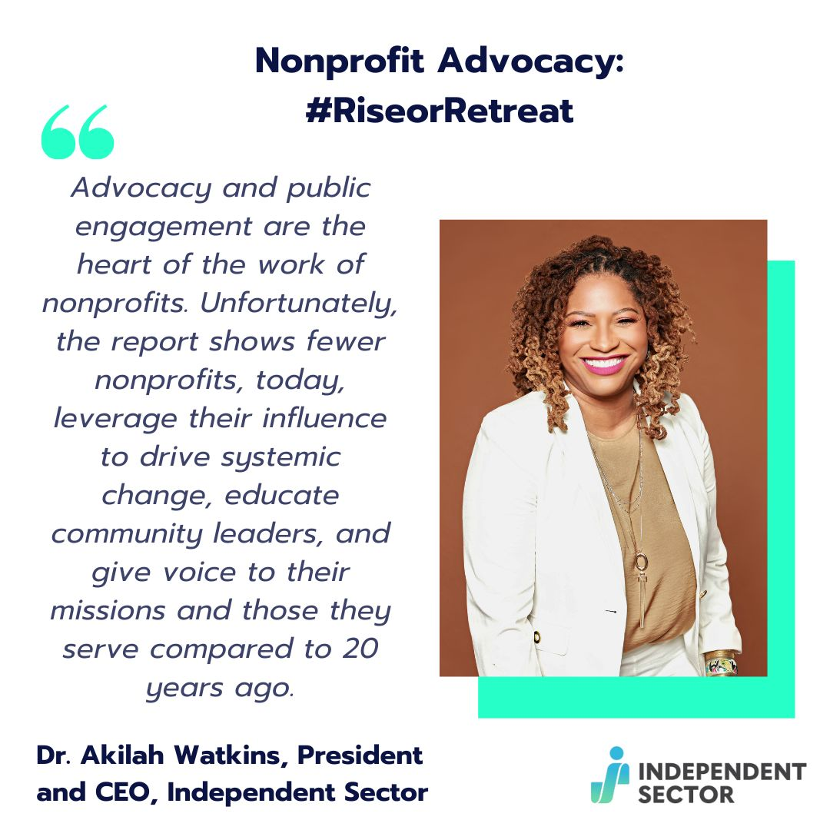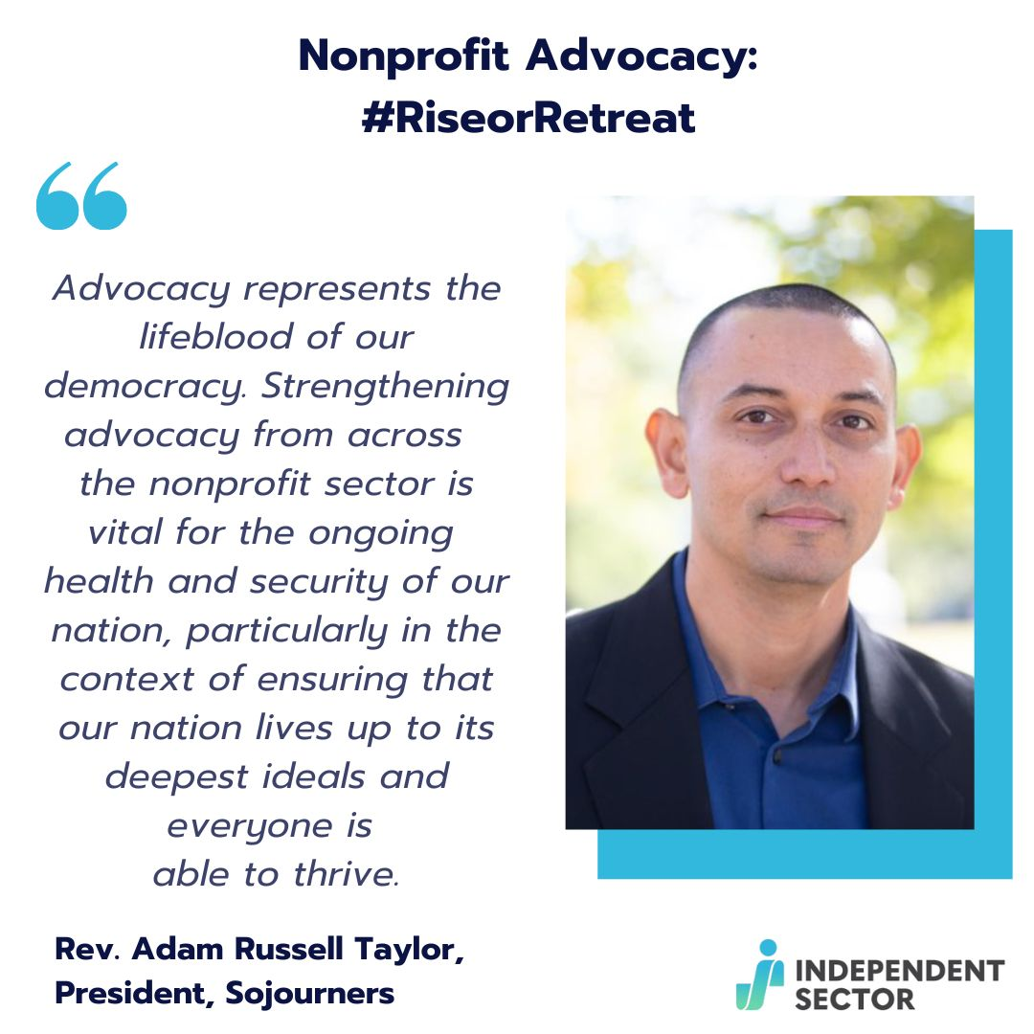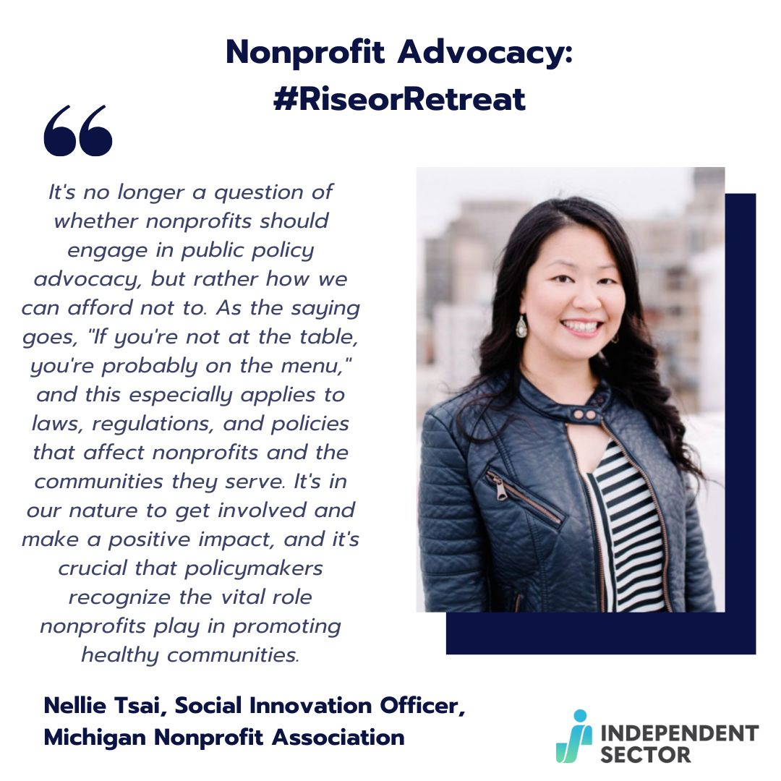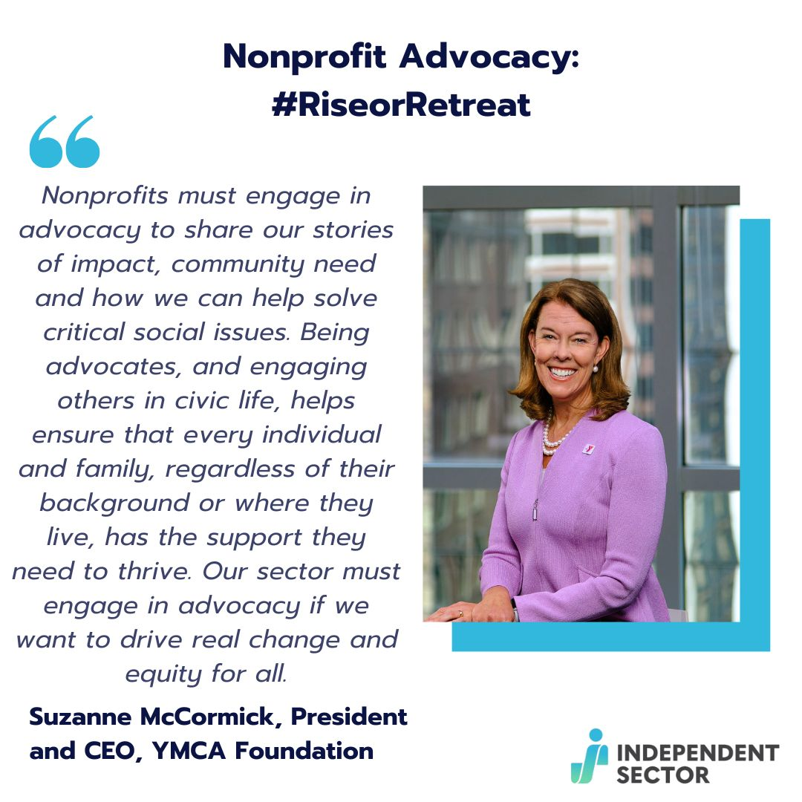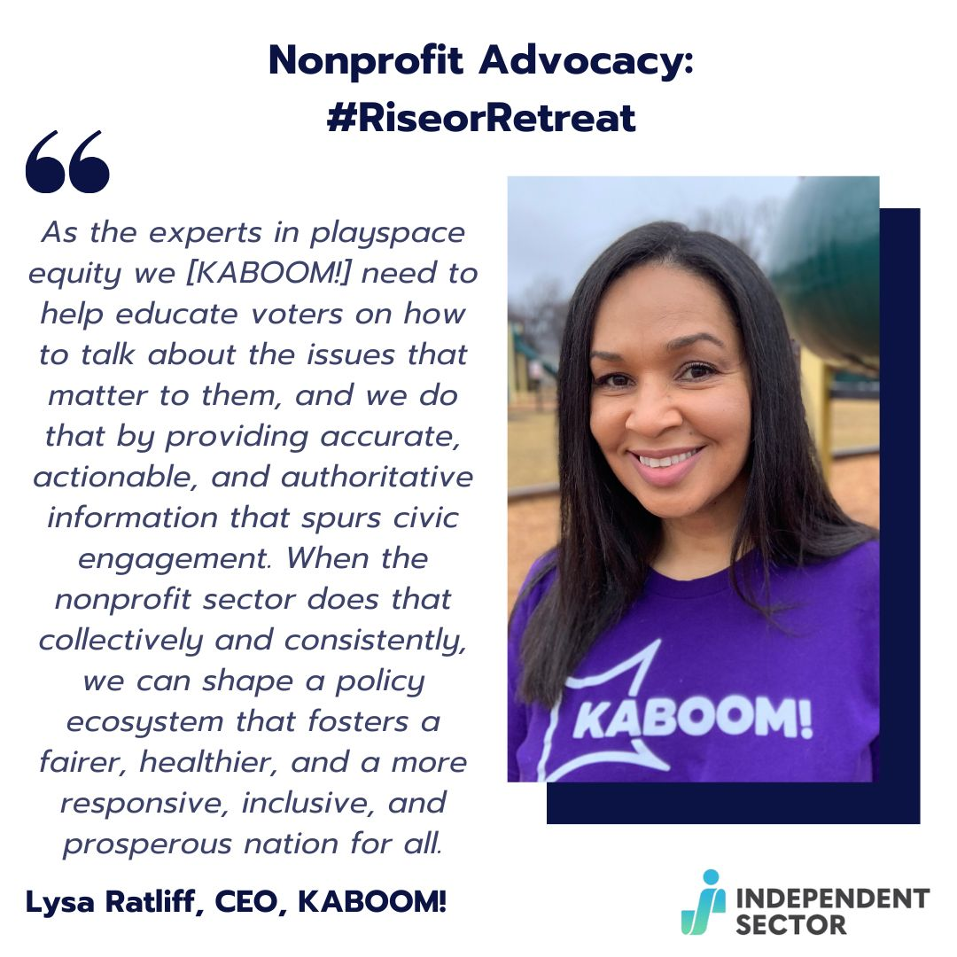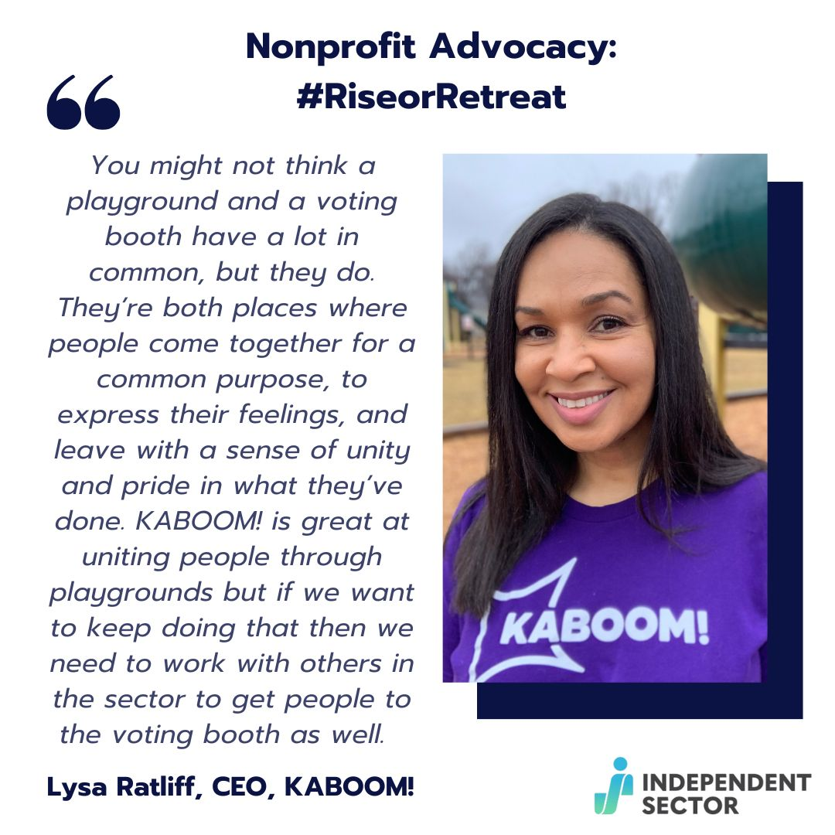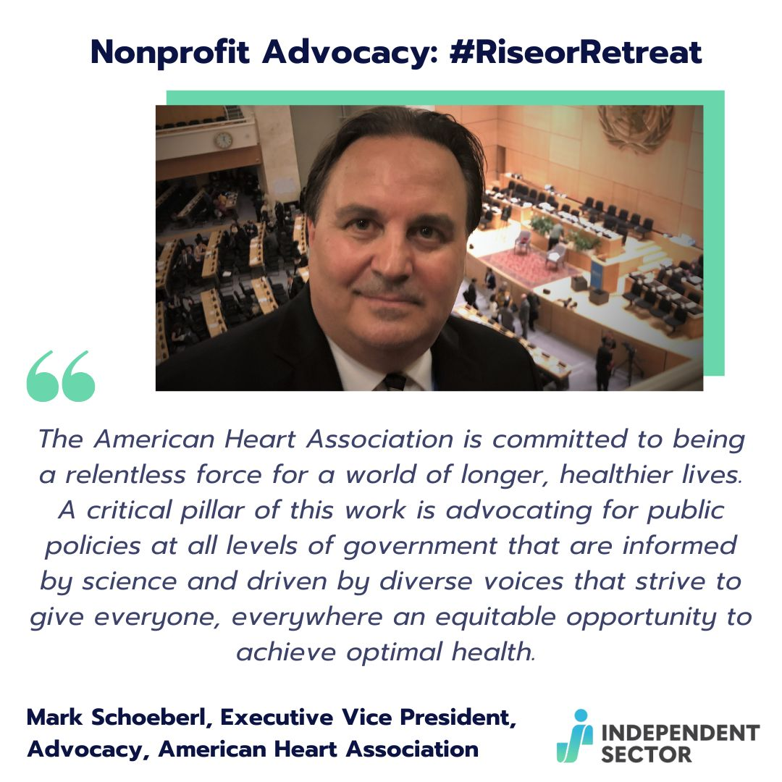

- Stories: No Caption needed, insert link on stories as swipe up and insert hashtag on the app.
